**Lab Exercises**

**Lab 1**

# Objective

You will learn how to install desktop and server operating systems as virtual machines running on a host machine, set up a virtual network and install the LAMP stack on the server.

1. **Oracle VirtualBox 6.1.12 installation**

Download the Oracle VirtualBox from the Internet at [Virtualbox 6.1.12](https://download.virtualbox.org/virtualbox/6.1.12/VirtualBox-6.1.12-139181-Win.exe) and save it to a directory on the lab machine.

If you are using a Mac, download the Oracle VirtualBox from V Install the Oracle Virtualbox

[irtualbox 6.1.12](https://download.virtualbox.org/virtualbox/6.1.12/VirtualBox-6.1.12-139181-OSX.dmg).

[You may wish to download and install Oracle VirtualBox Extension pack at O racle Virtualbox](https://download.virtualbox.org/virtualbox/6.1.12/Oracle_VM_VirtualBox_Extension_Pack-6.1.12.vbox-extpack)

E[xtension Pack so that you can have support for USB 2.0 and USB 3.0 devices.](https://download.virtualbox.org/virtualbox/6.1.12/Oracle_VM_VirtualBox_Extension_Pack-6.1.12.vbox-extpack)

1. **Ubuntu Server 20.04 LTS installation**

Sign in to Windows on a lab machine.

Download the Ubuntu Server Edition from the Internet at [u buntu server 20.04](http://releases.ubuntu.com/20.04/) and save it to a directory on the lab machine.

Now, it is advisable to skim the [Ubuntu Server Installation Tutorial](https://tutorials.ubuntu.com/tutorial/tutorial-install-ubuntu-server?_ga=2.110534853.1784532495.1532253192-58639039.1527485848&amp;0) from Ubuntu that will help you to anticipate what you will be required to act during the installation.

[Note the RAM requirement of **1 Gb** for a "live server" install by Recommended Minimum](https://help.ubuntu.com/lts/serverguide/preparing-to-install.html.en)

R[equirements of a Server Installation from Ubuntu.](https://help.ubuntu.com/lts/serverguide/preparing-to-install.html.en)

Start Oracle VM VirtualBox.

You need first create a VM then install an operating system on it. Press the **New** button at the top panel to start creating a new VM. Follow the screen to provide required information as follows.

在实验室计算机上登录Windows。

从互联网u buntu服务器20.04下载Ubuntu服务器版，并将其保存到实验室机器上的一个目录中。

现在，建议您浏览一下Ubuntu服务器安装教程，这将帮助您预测在安装过程中需要执行的操作。

请注意，对于“实时服务器”安装，建议的最低内存要求为1GB

从Ubuntu安装服务器的要求。

启动Oracle VM VirtualBox。

您需要首先创建VM，然后在其上安装操作系统。按下顶部面板上的New按钮开始创建新VM。按照屏幕提供所需信息，如下所示。

Name: **UbuntuServer**

Type: **Linux**

Versoin: **Ubuntu (64-bit)**

Memory size: **1024** MB

Hard disk file type: **VDI** (default)

File Location: **UbuntuServer** (default) File size: **10.00**GB

After you have created the VM, you will be presented with the following screen:

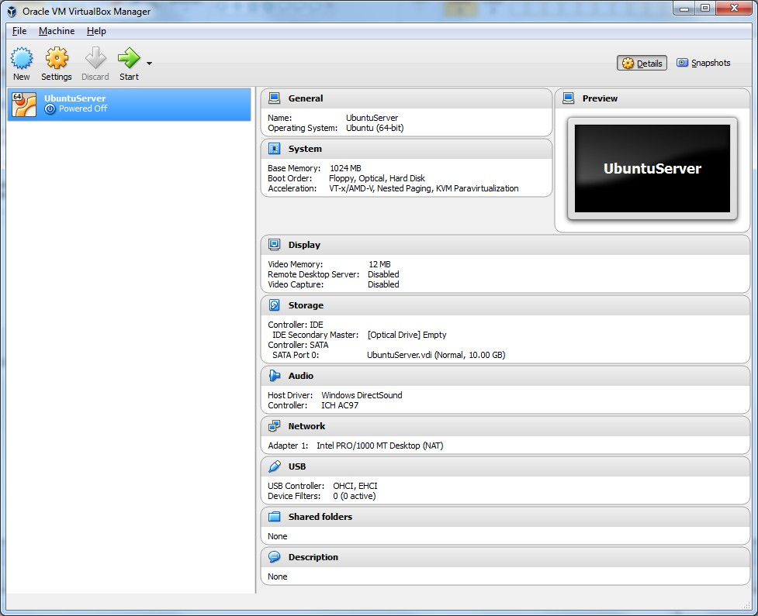

Now you need to attach the ISO file (insert a CD disc like on a real machine) to the VM by clicking at the **Storage** link on the **Details** pane of the VirtualBox Manager as above and you will be presented

with a Settings popup window.

Select the optical disc icon under *Controller: IDE*

Click the optical disc icon next to the *IDE Secondary Master* under *Attributes* panel and select

*Choose Virtual Disc File* and select the ISO file you just downloaded earlier.

Now it is ready to boot up the VM by pressing the **Start** button.

Follow the screen and instructions to install the Ubuntu Server. Accept default values offered by the installer but provide your own for Profile as follows. Note that if you are presented notifications about Auto capture keyboard or mouse pointer integration you can turn them off. When you are warned

about the loss of data on the disks, you can confirm to continue as it attributes to the virtual hard disk you have just created for the VM.

现在，您需要通过如上所述单击VirtualBox管理器详细信息窗格上的存储链接，将ISO文件（像在真实机器上一样插入CD光盘）附加到VM，您将看到

带有设置弹出窗口。

选择控制器：IDE下的光盘图标

单击“属性”面板下IDE辅助主机旁边的光盘图标，然后选择

选择虚拟磁盘文件，然后选择您刚才下载的ISO文件。

现在，按下开始按钮即可启动VM。

按照屏幕和说明安装Ubuntu服务器。接受安装程序提供的默认值，但提供您自己的配置文件，如下所示。请注意，如果您收到有关自动捕获键盘或鼠标指针集成的通知，您可以将其关闭。当你被警告时

关于磁盘上的数据丢失，您可以确认继续，因为它属于刚才为VM创建的虚拟硬盘。

Your name: (*Your name*) Your server's name: **server** Pick a username: **abc123**

Follow the instruction to restart the VM and omit the notice to remove the install media as it will be removed (ejected) automatically.

Sign in to your new Ubuntu server machine.

To test the successful installation, you can "ping -c 4 [www.baidu.com](http://www.baidu.com/)" and you should receive the responses.

按照说明重新启动VM，并忽略删除安装介质的通知，因为安装介质将自动删除（弹出）。

登录到新的Ubuntu服务器机器。

为了测试成功的安装，你可以“ping-C4 www.baidu.com”，你应该会收到回复。

1. **Ubuntu Desktop 20.04 LTS installation**

Download the Ubuntu Desktop Edition from the Internet at [ubuntu-20.04-desktop-amd64.iso](http://releases.ubuntu.com/20.04/) and save it to a directory on the lab machine.

Now, it is advisable to skim the [Ubuntu Desktop Installation Tutorial](https://tutorials.ubuntu.com/tutorial/tutorial-install-ubuntu-desktop?_ga=2.79362903.291131158.1532413540-58639039.1527485848&amp;0) from Ubuntu that will help you to anticipate what you will be required to act during the installation.

从互联网上的Ubuntu-20.04-Desktop-amd64.iso下载Ubuntu桌面版，并将其保存到实验室机器上的一个目录中。

现在，建议您浏览一下Ubuntu桌面安装教程，这将帮助您预测安装过程中需要执行的操作。

Note the RAM requirement of **2 Gb** and **dual core processor or better** for a desktop install by

R[ecommended system requirements](https://www.ubuntu.com/download/desktop) from Ubuntu.

Press the **New** button at the top-left corner to start creating a new VM. Follow the screen to provide required information as follows.

请注意，对于桌面安装，2 Gb和双核处理器或更好的RAM要求

Ubuntu推荐的系统要求。

按下左上角的New按钮开始创建新VM。按照屏幕提供所需信息，如下所示。

Name: **UbuntuDesktop**

Type: **Linux**

Versoin: **Ubuntu (64-bit)**

Memory size: **2048** MB

Hard disk file type: **VDI** (default)

File Location: **UbuntuDesktop** (default) File size: **10.00**GB

After you have created the VM, you attach the ISO file to the VM as you have done for the server installation.

Now you need to configure the VM to use two (2) processors by clicking at the **System** link on the

**Details** pane of the VirtualBox Manager and you will be presented with a Settings popup window.

创建VM后，将ISO文件附加到VM，就像服务器安装一样。

现在，您需要通过单击上的系统链接，将VM配置为使用两（2）个处理器

VirtualBox管理器的详细信息窗格，您将看到一个设置弹出窗口。

Select the **Processor** tab Set the **Processor(s)** to **2**

Set the **Video Memory** to **128MB** by clicking at **Display** in the left pane. This will improve the desktop performance.

Boot up the VM by pressing the **Start** button.

When you are presented with the following screen, press **Install Ubuntu** button.

单击左窗格中的“显示”，将视频内存设置为128MB。这将提高桌面性能。

按启动按钮启动虚拟机。

当出现以下屏幕时，按InstallUbuntu按钮。

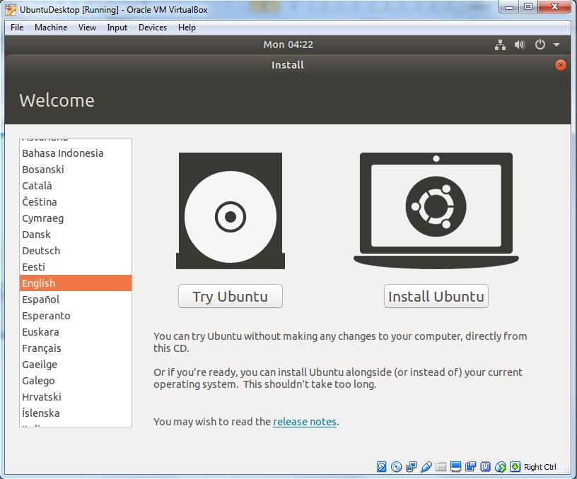

You are presented with the following screen, make sure you: select **Minimal installation**

# untick Download updates while installing Ubuntu

您将看到以下屏幕，请确保：选择“最小安装”

在安装Ubuntu时取消选中下载更新

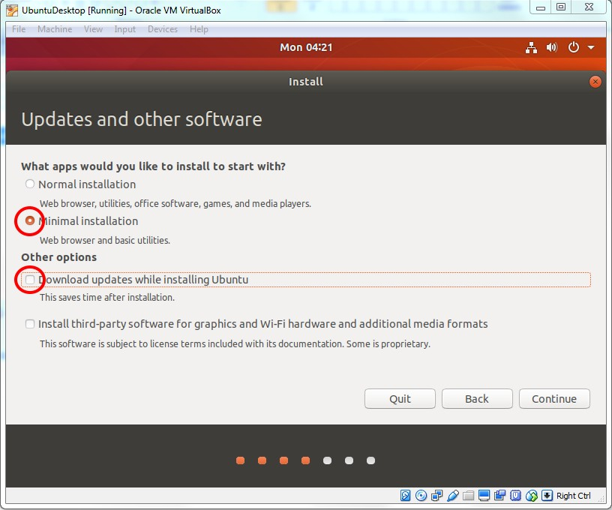

When you are warned to erase disk and install Ubuntu, you can simply press the **Install Now** button to continue as it attributes to the virtual hard disk you have just created for the VM.

Then follow the screen and instructions to install the Ubuntu Desktop. Accept default values offered by the installer (make sure you have correct time zone.)

Answer the Who are you ? questions as follows.

当警告您删除磁盘并安装Ubuntu时，您只需按install Now按钮继续，因为它属于您刚刚为VM创建的虚拟硬盘。

然后按照屏幕和说明安装Ubuntu桌面。接受安装程序提供的默认值（确保时区正确。）

回答问题你是谁？问题如下。

Your name: (*Your name*) Your server's name: **desktop** Pick a username: **abc123**

Follow the instruction to restart the VM and omit the notice to remove the install media as it will be removed (ejected) automatically.

Sign in to your new Ubuntu desktop machine.

To test the successful installation, you can open the Firefox web browser to point to any website Google and you should see the web page.

Now shutdown both VMs.

To shutdown the server, you can issue the command: shutdown -h now

To shutdown the desktop, you can press the switch button at the top-right corner and **Power off**.

按照说明重新启动VM，并忽略删除安装介质的通知，因为安装介质将自动删除（弹出）。

登录到新的Ubuntu桌面计算机。

要测试安装是否成功，您可以打开Firefox web浏览器指向Google的任何网站，您应该会看到该网页。

现在关闭两个虚拟机。

要关闭服务器，可以发出命令：shutdown-h now

要关闭桌面，您可以按右上角的开关按钮并关闭电源。

1. **Set up a virtual network**

Bring up the **Preferences** popup window from File menu item. Select Network from the left selection.

Press the icon with + to add new NAT network. Accept the **Name** as **NatNetwork.**

**从“文件”菜单项中打开“首选项”弹出窗口。从左侧选择中选择网络。**

**按+图标以添加新的NAT网络。接受名称为NatNetwork。**

1. **Attach the two VMs to the virtual network**

Select the server from the left pane of the VirtualBox Manager and click at the **Network** link on the

**Details** pane

Change the **Attached to** to **NAT Network** and **NatNetwork** should show in the **Name**. Do the same for the desktop.

Now start both VMs and sign in to both.

从VirtualBox管理器的左窗格中选择服务器，然后单击上的网络链接

详细信息窗格

更改附加到NAT网络，NAT网络应显示在名称中。对桌面执行同样的操作。

现在启动两个虚拟机并同时登录。

1. **Install LAMP applications on the server**

LAMP (Linux + Apache + MySQL + PHP/Perl/Python) are a popular setup for Ubuntu servers. There is a lot of applications using the LAMP application stack.

It is a good practice to bring up your system to the latest updates before you install any packages. Install the latest update from the Ubuntu repository using the following commands.

LAMP（Linux+Apache+MySQL+PHP/Perl/Python）是Ubuntu服务器的常用设置。有许多应用程序使用LAMP应用程序堆栈。

在安装任何软件包之前，最好先将系统更新到最新版本。使用以下命令从Ubuntu存储库安装最新更新。

sudo apt update sudo apt upgrade

To install a LAMP stack

sudo apt install lamp-server^

It is important to have the caret (^) at the end of the command, which suggests that the package is a meta-package for installing a number of packages together. However if you try to remove this meta- package you could remove a lot of dependencies that you are not expecting. So you can install LAMP stack using meta-package but do not remove it as a meta-package.

You can also install LAMP components individually. You can find a lot of tutorials to do so from a variety of sources.

在命令末尾使用插入符号（^）很重要，这表明该包是一个元包，用于同时安装多个包。然而，如果您试图删除这个元包，您可能会删除许多您不期望的依赖项。因此，您可以使用元包安装LAMP堆栈，但不要将其作为元包删除。

您也可以单独安装灯组件。您可以从各种来源找到许多教程来实现这一点。

1. **Test LAMP installation**

First find out the IP address of the server using the following command on the *server*.

ifconfig

You should find the IP from the output. It is likely to be 10.0.2.4 or similar.

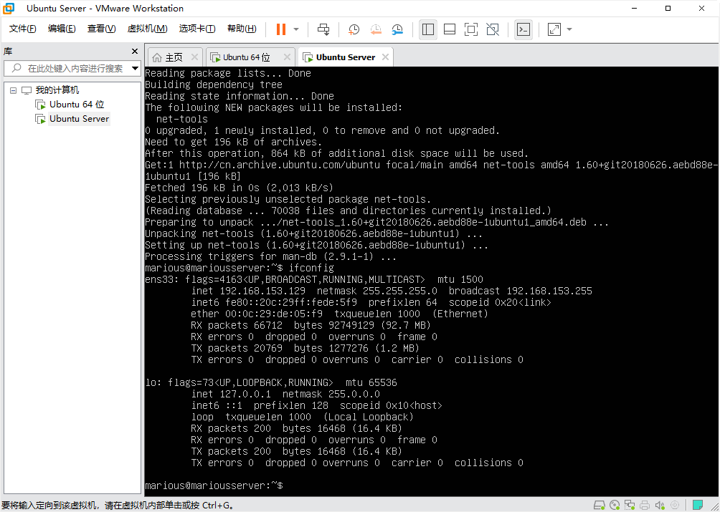

Point your Firefox browser on the *desktop* to the server IP and you should see the **Apaceh2 Ubuntu Default Page** from Apache web server on the server VM you have just installed.

Now create a PHP file on the *server* to test the PHP installation.

Use the command line editor pico to create a PHP file as follows.

sudo pico /var/www/html/info.php

Type in the following code:

<?php

phpinfo();

?>

and press ^X to save and exit.

Now point your Firefox browser on the *desktop* to *serverIP*/info.php and you should see the PHP information page showing the version at the top.

1. **Install the latest updates for the desktop VM**

We skipped to download and install the latest updates during installation. Now it is the time to do so.

Even you just installed a fresh OS but you will find a lot of updates ready for install. Ubuntu Linux releases various updates fairly frequently for security, bug fixes and feature enhancement.

*If you run out of time now, you can do this later and go ahead to the next stage to save your VMs to your USB device.*

Press the icon of nine (9) dots at the bottom-left corner to show all applications on the desktop and look to the program **Software Updater**. Run it and press **Install Now** when it is ready. It may take a while.

# Save your VMs

Shutdown both VMs.

Bring up the Preference popup windows from File menu of the VirtualBox Manager. Find out Default Machine Folder in the General panel. It should be like

C:\Users*yourUserID*\VirtualBox VMs

Please make sure to insert your USB 3.0 device into the blue USB 3.0 socket on the lab machine. Copy the entire folder to your UBS device.

# Submission and mark

There is no mark allocated to this lab and it is assumed you have completed this work. You will need to work on these VMs from the next lab through the whole session.